

Lab :7
Name | Sap id | Program | Email
Laraib salam | 61996 | BSCS | 61996@students.riphah.edu.pk

Submitted to: Mam Rehana sanam

Class tasks 1
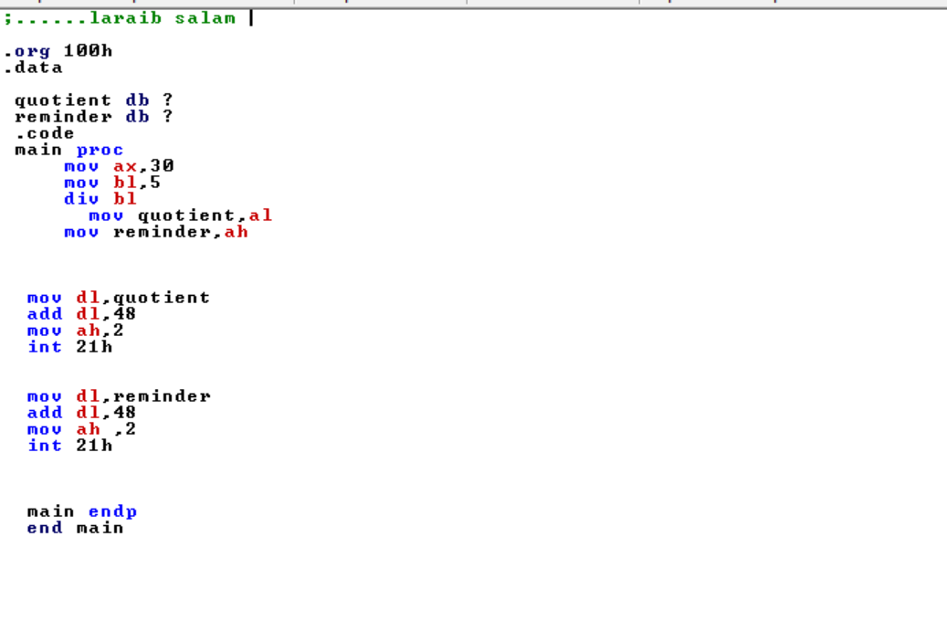
Output
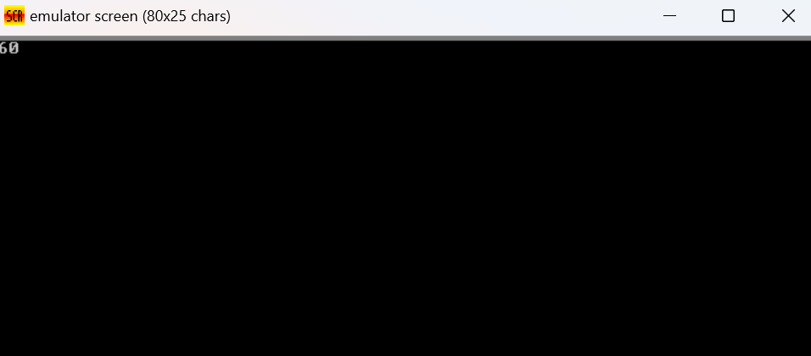

Class Tasks : 2
;......laraib salam

.model small
.data

qt db "quotient $"
rm db "reminder $"
.code
main proc
mov ax,27
mov bl,5
div bl
mov cl,al
mov ch,ah
mov ax,@data
mov ds,ax
mov dx,offset qt
mov ah,9
int 21h
mov dl,cl
add dl,48
mov ah,2
int 21h

mov dx,10
mov ah,2
int 21h
mov dx,13
mov ah,2
int 21h

mov ax,@data
mov ds,ax
mov dx,offset rm
mov ah,9
int 21h

mov dl,ch
add dl,48
mov ah,2
int 21h

mov ah,4ch
int 21h

main endp
end main

output

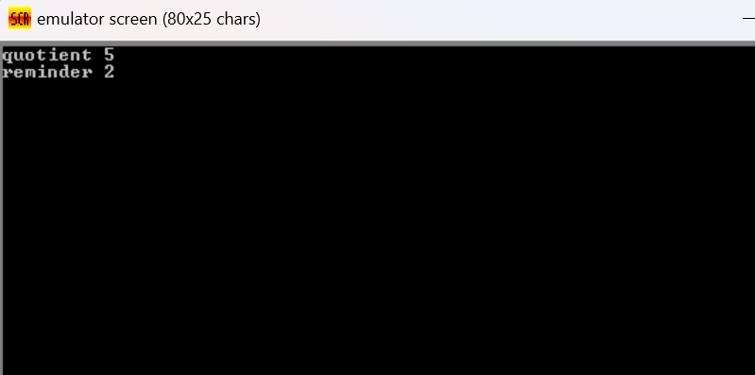

Home tasks :1
;laraib salam
.model small
.stack 100h
.data
msg1 db
msg2 db 0Dh,0Ah,
msg3 db 0Dh,0Ah,
num1 db ?
num2 db ?
result db ?
.code
main proc
mov ax, @data
mov ds, dx

mov dx, offset msg1
mov ah, 09h
int 21h

mov ah, 01h
int 21h
sub al, 30h

mov dx, offset msg2
mov ah, 09h
int 21h

mov ah, 01h
int 21h
sub al, 30h
mov num2, al

mov al, num1
mov bl, num2
mul bl
mov result, al

mov dx, offset msg3
mov ah, 09h
int 21h

mov dl, result
add dl, 30h
mov ah, 02h
int 21h

int 21h
main endp
end main

ret
output
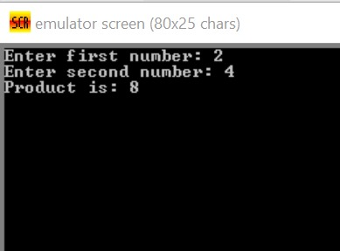
Tasks :2
.... laraib salam
.model small
.stack 100h
.data
msg1 db
msg2 db 0Dh,0Ah,
num db ?
result db ?

.code
main proc
mov ax, @data
mov ds, ax

mov dx, offset msg1
mov ah, 09h
int 21h

mov ah, 01h
int 21h
sub al, 30h
mov num, al

mov bl, num
mul bl
mov result, al

mov dx, offset msg2
mov ah, 09h
int 21h

mov dl, result
add dl, 30h
mov ah, 02h
int 21h

mov ah, 4Ch
int 21h
main endp
end main
output

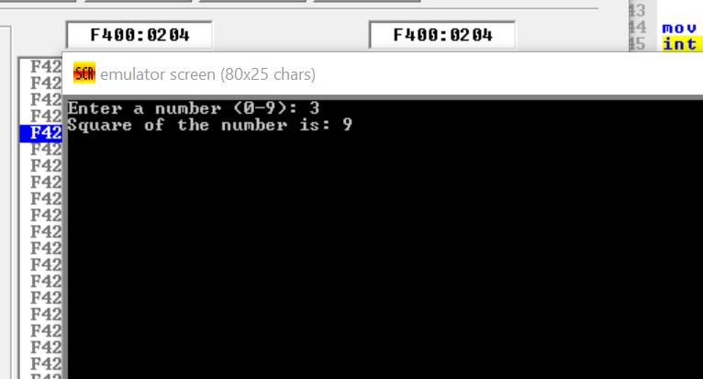
Tasks :3
;laraib salam
org 100h

.model small
.stack 100h
.data
msg1 db 'Enter a number: $'
msg2 db 0Dh,0Ah, 'Cube of the number is: $'
num db ?
result db ?
.code
main proc
mov ax, @data
mov ds, ax

mov dx, offset msg1
mov ah, 09h
int 21h

mov ah, 01h
int 21h
sub al, 30h
mov num, al

mov al, num
mov bl, num
mul bl
mov bl, al
mov al, num
mul bl
mov result, al

mov dx, offset msg2
mov ah, 09h
int 21h

mov dl, result
add dl, 30h
mov ah, 02h
int 21h

mov ah, 4Ch
int 21h
main endp
end main

ret

output
